Intelligent Disaster Early Warning and Evacuation Management System

AI-Powered Kerala Flood Early Warning and Smart Evacuation Management System Using GIS

Assignment 2

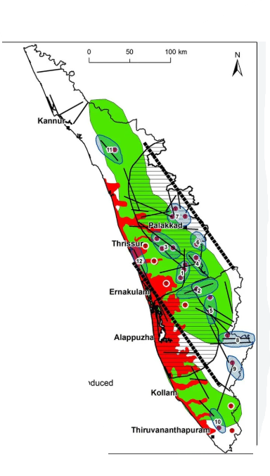

Institute name | SIMATS Engineering
Team / Batch | 2
Team Members | Nikhil Kumar Reddy Kadiveti (192425031)  Jaswanth. S (192525214)  Sanjay Manesh M (192511362)  Venkata Kumar Reddy (192311350)  N. Kalyan Reddy (192424232)  Surya Krishna Teja Yandra (192425065)  K Sujith Sai Vighnesh (192311199)  Harsha Vardhan Reddy (192372215)
Assignment | 2
Date | 01/09/2026

1. Introduction and Project Context
The assigned problem statement, “Intelligent Disaster Early Warning and Evacuation Management System,” focuses on designing, planning, and building a full-stack, containerized platform that integrates IoT sensors, weather and seismic monitoring, AI/ML, GIS, cloud technologies, and emergency communication to improve disaster preparedness and response. The problem statement requires the application of Agile project management using Scrum, detailed requirements engineering, scalable software architecture, full-stack development, Docker-based containerization, GitHub collaboration, testing, and reliable deployment.
Based on this broader problem, our team selected the specific application domain “AI-Powered Kerala Flood Early Warning and Smart Evacuation Management System Using GIS.” Kerala was selected because its geographical and climatic conditions make flood preparedness and early warning particularly important. Our system focuses on using multiple sources of environmental information, including IoT sensor data, rainfall and weather observations, historical flood records, climate-related parameters, and satellite imagery, to identify changing flood conditions. The central objective is to predict the likelihood of flooding in vulnerable areas in advance and communicate this risk to authorities and citizens so that preventive action and evacuation can be initiated before the situation becomes critical.
The proposed system processes the collected data using AI/ML techniques to generate a flood-risk probability or percentage for a particular location over a future period such as the next few days or weeks. Instead of limiting the prediction to a simple “flood” or “no flood” output, a probability-based approach provides authorities with a better indication of the level of risk. The prediction is then connected with GIS functionality to visualize vulnerable regions, identify safe zones and shelters, and recommend suitable evacuation routes. The complete system is supported by a web-based authority dashboard and citizen-oriented emergency communication and reporting facilities.

2. Individual Contributions of the Eight Members
The project was divided into interconnected areas so that each member could make a meaningful technical contribution while contributing to the same overall objective.
Member 1 – Requirements, Agile Management and System Design: Contributed to analysing the original disaster-management problem, identifying stakeholders, developing user stories and requirements, prioritizing the product backlog, and designing the overall system architecture. This contribution mainly applied Unit 1 and Unit 2 concepts, particularly Scrum, feasibility analysis, requirements engineering, and architectural design.
Member 2 – Environmental Data Collection and Preprocessing: Worked on identifying and preparing historical flood records, rainfall and weather data, sensor readings, and other environmental parameters required by the prediction system. Data cleaning, normalization, handling missing values, and preparation of datasets were important parts of this contribution. This applied requirements, data-processing, and full-stack development concepts from Units 2 and 3.
Member 3 – AI/ML Flood Prediction: Developed the core prediction component that analyses environmental and historical data to estimate the probability of flooding. Feature selection, preprocessing, model training, prediction, and evaluation were considered in this module. The decision to generate a risk percentage rather than only a binary prediction makes the system more useful for early decision-making. This contribution primarily applied the AI/ML and emerging-technology concepts from Unit 5.
Member 4 – Satellite, Climate and Environmental Data Integration: Focused on incorporating satellite imagery and climate/environmental information into the overall data pipeline. Combining different data sources was important for improving the information available to the prediction model. This work demonstrated the application of emerging technologies, data integration, and scalable system concepts from Units 3 and 5.
Member 5 – GIS Mapping and Smart Evacuation: Developed the GIS component for visualizing flood-prone areas, affected regions, safe zones, shelters, and evacuation paths. The evacuation logic considers factors such as road accessibility, distance, possible flooding, and population distribution. This contribution connected requirements engineering, architectural design, spatial information processing, and data-driven application development from Units 2 and 3.
Member 6 – Emergency Alerts and Citizen Reporting: Worked on the citizen-facing communication component, including location-specific warnings, emergency notifications, and incident reporting. Citizens can report blocked roads, dangerous locations, or people requiring assistance, allowing information to flow back to emergency authorities. This contribution applied user-centric design, full-stack development, API integration, and software-quality concepts from Units 1, 3, and 4.
Member 7 – Authority Dashboard, Shelter and Resource Management: Developed the authority-side dashboard for viewing risk levels, affected locations, evacuation progress, shelter occupancy, and available resources. This module helps authorities make faster decisions by presenting important information through a centralized interface. It applied full-stack development, requirements engineering, monitoring, and dashboard-oriented system design from Units 2, 3, and 4.
Member 8 – Backend Integration, Security, Testing and Deployment: Focused on integrating the different services through backend APIs and supporting collaborative development, testing, Docker-based deployment, authentication, and role-based access control. This contribution ensured that the individual modules could function together as one secure and maintainable platform. It directly applied concepts from Units 3, 4, and 5, including Git/GitHub, Docker, testing, DevOps, security, and maintainability.

3. Challenges and Learning Gained
One of the main challenges was integrating heterogeneous data because sensor, weather, historical, satellite, and climate datasets can differ in format, frequency, accuracy, and availability. Another challenge was developing a prediction approach that provides useful early warnings without creating unnecessary panic through excessive false alarms. We learned that AI predictions should support, rather than completely replace, human decision-making, especially in safety-critical applications. We also faced challenges in coordinating eight members working on interconnected modules, which highlighted the importance of Scrum, version control, clear interfaces, documentation, and code reviews.
Through the project, we gained practical knowledge of Agile development, requirements analysis, system architecture, full-stack development, AI/ML, GIS, Git/GitHub, Docker, testing, DevOps, security, and emerging technologies. More importantly, we learned how these individual software-engineering concepts must be combined to solve a complex real-world problem.

4. SDG and Course Outcome Connection
The project strongly supports
- SDG 11 – Sustainable Cities and Communities by improving disaster preparedness, evacuation planning, and community resilience.
- It contributes to SDG 13 – Climate Action by using climate and environmental information for disaster-risk prediction and adaptation.
- It also supports SDG 3 – Good Health and Well-being by enabling earlier warnings, safer evacuation, and faster emergency response.
The assignment contributed to the mapped course outcomes by requiring us to analyse a real-world problem, derive and prioritize software requirements, design a scalable architecture, implement full-stack and AI-enabled components, collaborate using modern development practices, apply testing and DevOps principles, and consider ethical, secure, and sustainable software development. The project therefore transformed the concepts studied across Units 1–5 into an integrated practical solution. Overall, our work demonstrates how software engineering, AI/ML, GIS, cloud technologies, and collaborative development can be combined to create a proactive and data-driven disaster management system capable of supporting better decisions and improving community resilience.

